SYSTEM DESIGN RATIONALE

University Course Registration, Timetable & Attendance Management System
CO2203 – Object Oriented Programming
Architecture & Design Specification

: 24/ENG/119
: 24/ENG/116
: 24/ENG/152

R.N. KESHAN
M.P.D.M. PITIYEGEDARA
W.K.P.M. THILAKARATHNE
Group Name :UniVerse

Group Members :
UML Design
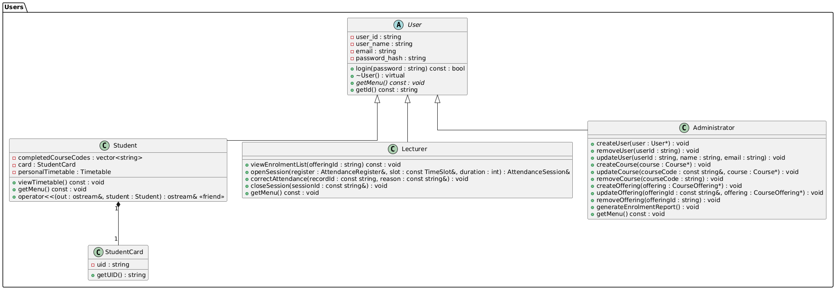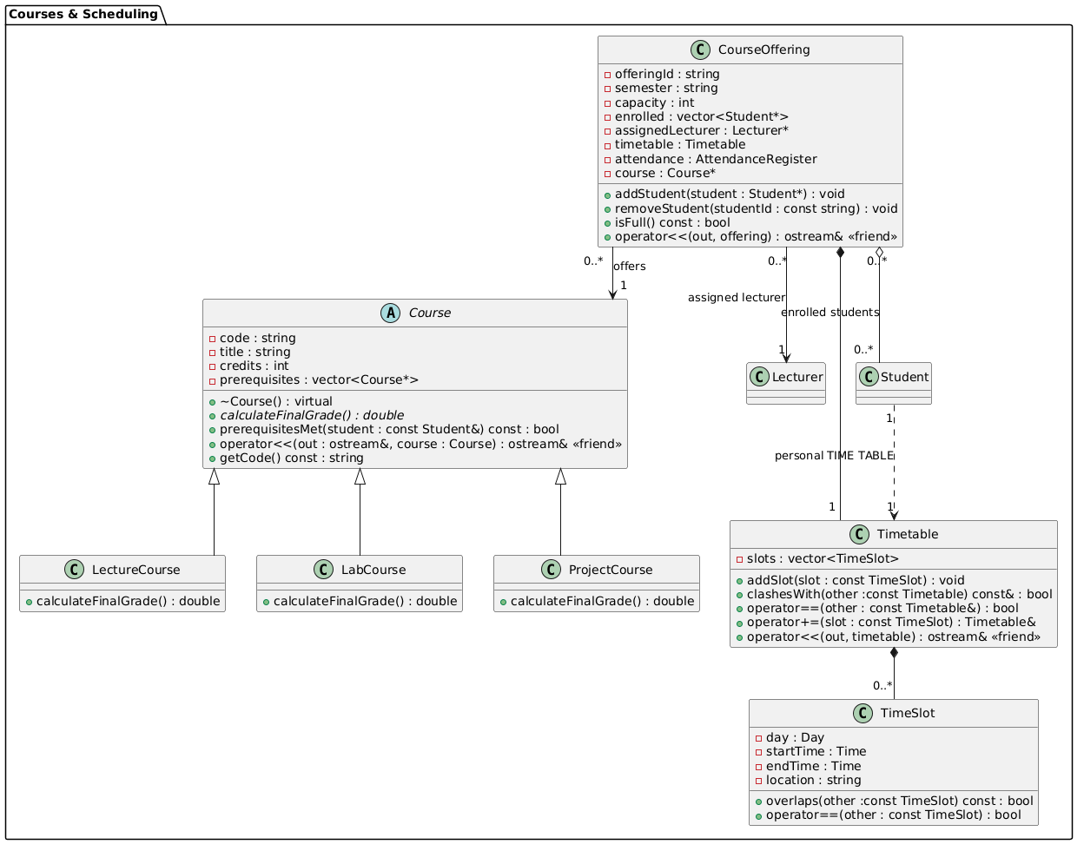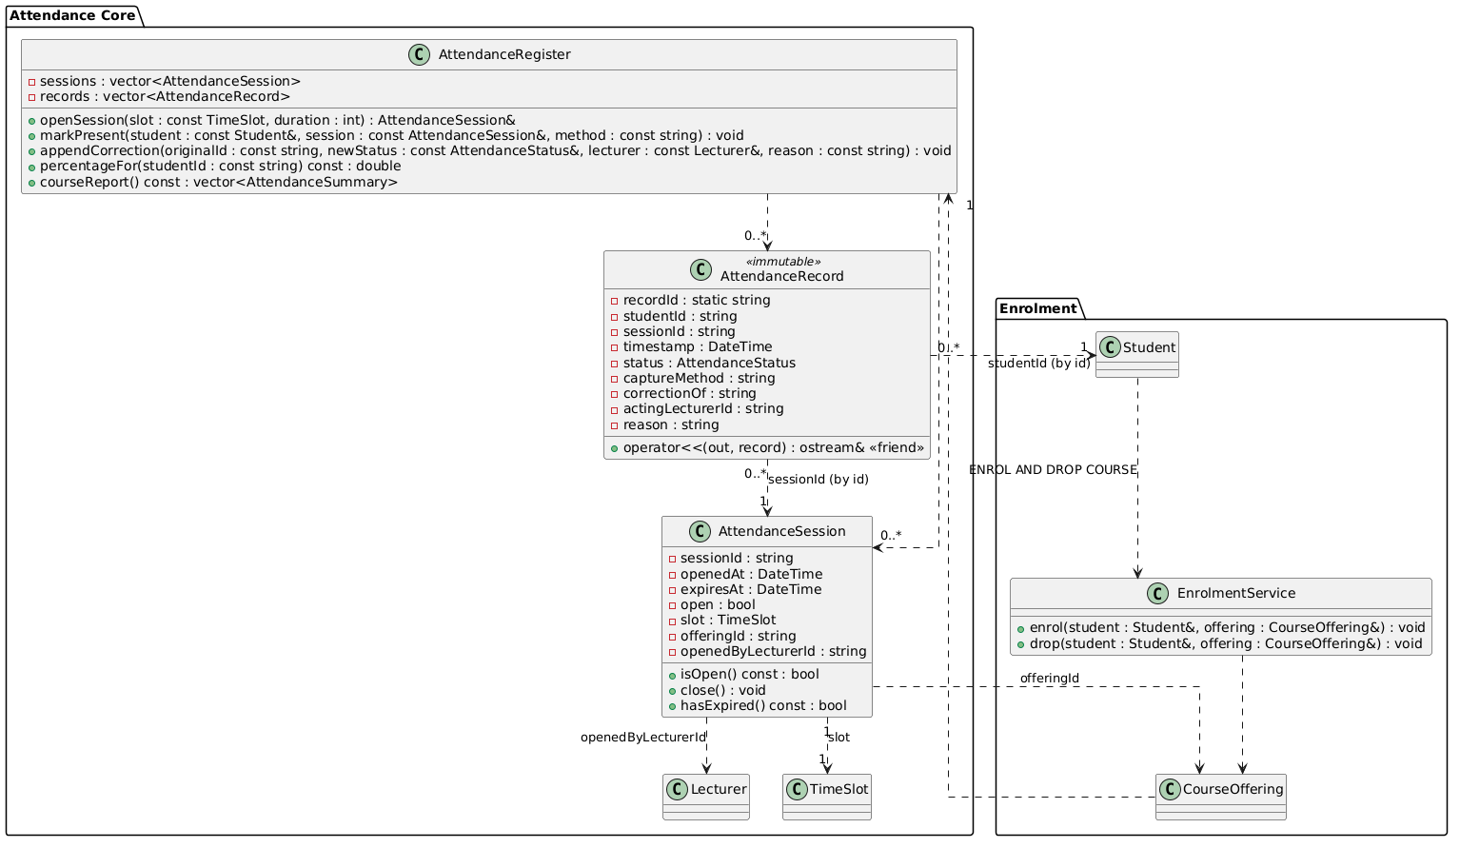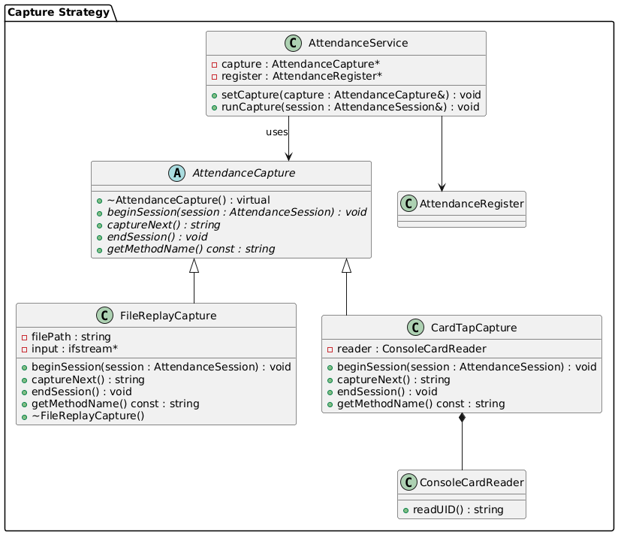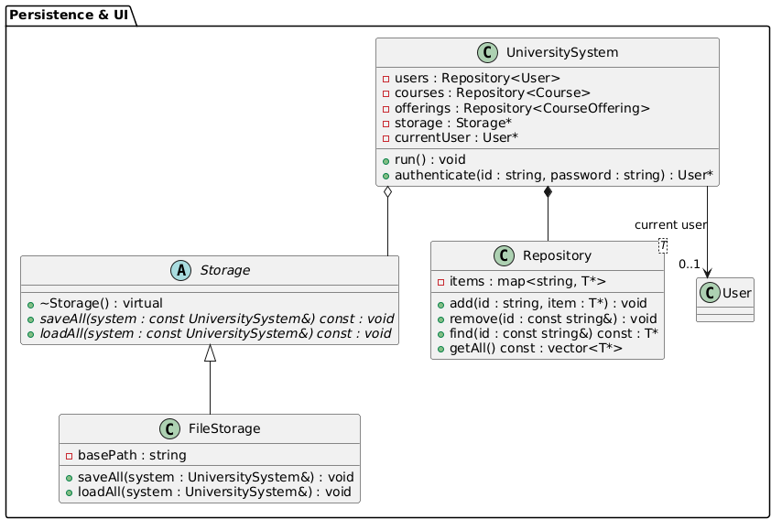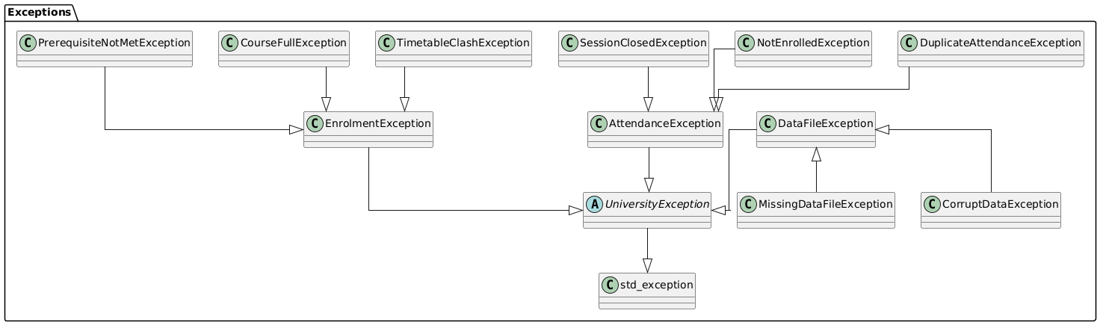
01
02
03
- Introduction
This system is developed for essential tasks such as university course registration, releasing timetables through it and marking attendance through it. So, this system basically developed based on C++ with object-oriented programming concepts. This system provides few roles such as Student, Lecturer and administrator. This can provide functionalities for management of timetables, attendance, registrations, reporting and store system data as well.
In this system we have used concepts such as abstraction, polymorphism, encapsulation, inheritance, aggregation, templates, operator overloading and file handling to create a realistic and professional for digital university.
The system contains six focus areas. It includes users, courses and scheduling, attendance, capture strategy and persistence and user interface.

- Class Hierarchy
  - User Hierarchy
There is an abstract user base class that has three derived classes as Student, Lecturer and Administrator for the user hierarchy. There are few attributes that are same for all of them such as user id, username, email, password and login functionality. They are also unique operations according to their role as well.
By using getMenu() function polymorphism can be implemented through pure virtual. Each derived class performs their own tasks of this function. It helps with the appropriate menu based on their role. After verifying the credential for the login system this system will interact with User*pointer and calls getMenu(). Then system can automatically recognize the user role as well.
Then the hierarchy can also increase the reusability of the code and minimize the complexity of it. Making edits such as adding and removing also makes it easier with this system.

  - Course Hierarchy
There is an abstract user base class that has three derived classes such as LectureCourse, LabCourse and ProjectCourse for the course hierarchy. This also includes common attributes such as course code, title, credits. Each course can calculate their final marks as well.
Polymorphism is achieved through the pure virtual function calculateFinalGrade(). Each derived class
provides its own implementation based on the course type.
This hierarchy also helps to improve reusability, avoids duplications for same thing for each class. Modifications of the system are also provided here as well.

  - Attendance Capture Hierarchy
The AttendanceCapture structure differentiates the attendance input method from the attendance processing logic by establishing a shared interface via the abstract AttendanceCapture class, which is realized by FileReplayCapture and CardTapCapture. AttendanceService connects with the active capture method via a unique_ptr, allowing various attendance capture strategies to be chosen during runtime without altering the attendance management process. The required FileReplayCapture allows for testing with recorded data, whereas CardTapCapture (Simulated Card Tap) tracks attendance by scanning each student's StudentCard, giving the system adaptability and straightforward extensibility.

  - Storage Hierarchy
The Storage class is like a plan that has methods to save and load data. These methods are saveAll and loadAll. They make it easy to store and get data. FileStorage does what the Storage class says it should do. This helps the UniversitySystem work, with kinds of storage. It also makes it easy to change how data is stored on without changing how the UniversitySystem works. The Storage class and FileStorage make this possible.

04
  - Exception Hierarchy
The system uses a list of exceptions. UniversityException is the class. It has exceptions like ValidationException and EnrollmentException and AttendanceException. These exceptions help the system know what kind of error is happening. This way the system can handle errors in a way. It can catch all the exceptions with the main class UniversityException. It can also give different error messages for different types of errors. This makes it easy to know what went wrong. The system can handle all the UniversityException errors in one place. It can still give specific error messages, for ValidationException errors or EnrollmentException errors or AttendanceException errors.

- Composition vs. Aggregation
Composition implies ownership and shared lifetimes, whereas aggregation implies a looser connection between two independently existing objects. In our design, composition is applied whenever Student has StudentCard and Timetable, CourseOffering has Timetable and AttendanceRegister, Timetable has its TimeSlot objects, AttendanceRegister has its AttendanceSession and AttendanceRecord objects, AttendanceSession has its TimeSlot, CardTapCapture has ConsoleCardReader, and UniversitySystem has its repositories. The contained objects are kept as member objects and are destroyed along with their owners. In contrast, aggregation is applied between CourseOffering and Student because the former contains only non-owning pointers to students; students may live independently, be enrolled in more than one course offering, and do not get deleted when a course offering is deleted. Moreover, aggregation is applied between UniversitySystem and Storage because the former just refers to Storage, which is externally created and is not managed by the UniversitySystem.

- Mandatory OOP Requirements
OOP Requirement | Where in the UML | Why it is Used
Classes and Objects | All classes (User, Course, Attendance Session, Attendance Register, etc.) | For representing real-world entities of the university as objects with its own data and behavior.
Encapsulation | Private data member(-)s with public member functions in all classes | Prevents direct access to internal data and provides controlled access via member functions.
Inheritance | User -> Student, Lecturer, Administrator; Course -> LectureCourse, LabCourse, ProjectCourse; AttendanceCapture -> FileReplayCapture, CardTapCapture; Storage -> FileStorage; and the exception hierarchy. | Prevents code repetition and provides specialized behavior in derived classes.
Polymorphism | Pure virtual functions such as User::getMenu(), Course::calculateFinalGrade(), AttendanceCapture methods, and Storage::saveAll() / loadAll() | It allows the system to access derived classes implementations via base class pointers or references.
Abstract Classes | User, Course, Attendance Capture, Storage, University Exception | It does not allow creating objects directly and provides interfaces for the derived classes.
Composition | Student *-- StudentCard; CourseOffering *-- Timetable; Timetable *-- TimeSlot; | It represents strong containment where the contained objects rely on the lifetime of the containing object.
Aggregation | Student–Course Offering,  05 | It represents associations where the objects do not depend on each other’s lifetimes.
Templates | Repository<T> | It provides a reusable generic repository, which will allow storing different object types without replicating code.
Exception Handling | University Exception hierarchy and throw/catch in validation and enrolment operations | Handles run-time exceptions gracefully and gives informative error messages.
File Handling | FileStorage, Storage::saveAll(), Storage::loadAll(), and FileReplayCapture::input. | It allows saving/loading the state of the application for persistent storage.
Operator Overloading | operator<< in Student, Course, CourseOffering, Timetable, and AttendanceRecord; operator== in TimeSlot and Timetable; Timetable::operator+=. | Helps in creating formatted output of the objects.
STL Containers & Smart Pointers | vector, map | It helps manage collections of objects efficiently and automatically handles memory.

- Selected Interactive Attendance Capture Method
The system optimizes Option B – Simulated Card Tap as the interactive attendance capture method. This approach was taken since it is close to a real university card-based attendance system and it is simple to implement in a console application. Every undergraduate receives an assigned unique Student Card, and the attendance of them are read through the card UID using ConsoleCardReader and records attendance through CardTapCapture providing a realistic, modular, and easily extensible solution.

- Mapping the Design to Three Member Roles
Member | Main Responsibility | Related Classes/Modules
Member 3 | User and course management | User, Student, Lecturer, Administrator, Course, Lecture Course, Lab Course, and Project Course
Member 2 | Enrolment and timetable management | Course Offering, Time Slot, Enrolment operations, prerequisite checking, and timetable conflict handling
Member 1 | Attendance and data persistence | Attendance Session, Attendance Register, Attendance Record, Attendance Capture, CardTapCapture, FileReplayCapture, Storage, and File Storage

The system is partitioned so that every individual is accountable for an independent functional module with a clearly defined public interfaces. This ensures reduced development conflicts, allows individuals to work independently, and supports easier integration and testing of the entire system.
06
Interface Agreement
Exposed by  (Class and Owner) | Public Function | Used by | Purpose
User  (Member 3) | getId() const | EnrolmentService::enrol()/drop()  (Member 2)  AttendanceRegister::markPresent()/appendCorrection()  (Member 1) | Providing Student and Lecturer IDs without exposing private data
StudentCard  (Member 3) | getUID() const | CardTapCapture::captureNext()  (Member 1) | Matching a tapped card UID with the correct student
Course  (Member 3) | prerequisitesMet(const Student&) const | EnrolmentService::enrol()  (Member 2) | Checking prerequisites before enrolment
Course  (Member 3) | getCode() const | EnrolmentService::enrol()  (Member 2) | Obtaining the course code for enrolment and prerequisite checks
EnrolmentService  (Member 2) | enrol(Student&, CourseOffering&) | Student::getMenu() enrolment action  (Member 3) | Enrolling a student after all required checks pass
EnrolmentService  (Member 2) | drop(Student&, CourseOffering&) | Student::getMenu() drop action  (Member 3) | Removing a student from a course offering
CourseOffering  (Member 2) | isFull() const | Student/Administrator menu logic  (Member 3) | Displaying whether an offering has available capacity
TimeSlot  (Member 2) | overlaps(const TimeSlot&) const | AttendanceRegister::openSession()  (Member 1) | Preventing overlapping attendance sessions
Timetable  (Member 2) | operator<<(ostream&, const Timetable&) | Student::viewTimetable()  (Member 3) | Displaying a student's personal timetable
AttendanceRegister  (Member 1) | openSession(const TimeSlot&, int) | Lecturer::openSession()  (Member 3) | Creating a new attendance session for a lecturer
AttendanceRegister  (Member 1) | appendCorrection(originalId, status, lecturer, reason) | Lecturer::correctAttendance()  (Member 3) | Adding an auditable attendance correction
AttendanceSession  (Member 1) | close() | Lecturer::closeSession()  (Member 3) | Stopping further attendance capture for a session
AttendanceRegister  (Member 1) | courseReport() const | Administrator::generateEnrolmentReport()  (Member 3) | Providing attendance summaries for administrative reporting
AttendanceService  (Member 1) | setCapture(AttendanceCapture&) | Lecturer attendance workflow  (Member 3) | Selecting file-replay or card-tap attendance capture
AttendanceService  (Member 1) | runCapture(AttendanceSession&) | Lecturer attendance workflow  (Member 3) | Running the selected capture method for an open session
Storage  (Member 1) | saveAll(const UniversitySystem&) | UniversitySystem::run()  (Owner to be assigned) | Saving application data when required or before exit
Storage  (Member 1) | loadAll(UniversitySystem&) | UniversitySystem::run()  (Owner to be assigned) | Loading saved application data during startup
07

